 **Willenhall Oak medical Centre**

**SURGERY NEWSLETTER**

**September/ October 2018**



**One in 3 people in Coventry and Warwickshire are**

**entitled to a free flu vaccination this winter.**

As flu season approaches, we will begin our flu clinics this month. We will be holding clinics on the following dates and times:

Tuesday 18th September: 09:00—12:00 – OVER 65’S ONLY

Tuesday 25th September: 09:00—12:00 – OVER 65’S ONLY

Tuesday 2nd October: 09:00—12:00

Tuesday 9th October: 14:30- 18:00

MORE DATES TO BE ANNOUNCED

If you’re eligible for a vaccination, just drop in on any of these dates. If you’re unsure on your eligibility or have any questions; please ask at reception.

This year, three types of flu vaccine will be used in the flu programme. This will benefit patients by ensuring that they have the most suitable vaccine that gives them the best protection against flu. The three vaccines are:

* Adjuvanted trivalent flu vaccine (aTIV) - This is licensed for people aged 65 years and over and **is AVAILABLE NOW**
* Quadrivalent vaccine (QIV) - This is recommended for children aged from 6 months to 2 years and in adults from 18 years to less than 65 years of age who are at increased risk from flu because of a long term health condition. Due to a manufacturing problem this will be **AVAILABLE FROM END OF SEPTEMBER**
* In general practice and via school based programmes:

**Live attenuated influenza vaccine (LAIV)** - This is a nasal spray and is licensed

for children and young people from 2 years old to less than 18 years of age. The

age groups targeted in England for this vaccine in 2018/19 are two and three year

olds (through their GP surgery) and school aged children in reception class through

to Year 5 (through schools- **AVAILABLE FROM END OF SEPTEMBER**

One in 3 people in Coventry and Warwickshire are entitled to a free

flu vaccination this winter.

As flu season approaches, we will begin our flu clinics this month. We

will be running drop-in sessions on the following dates and times:

**Tuesday 18th September: 09:00—12:00 – OVER 65’S ONLY**

**Tuesday 25th September: 09:00—12:00 – OVER 65’S ONLY**

**Tuesday 2nd October: 09:000—12:00**

**th October: 08:30—10:30**

**th October: 08:30—10:30**

If you’re eligible for a vaccination, just drop in on any of these dates. If

you’re unsure on your eligibility or have any questions; please ask at

reception.

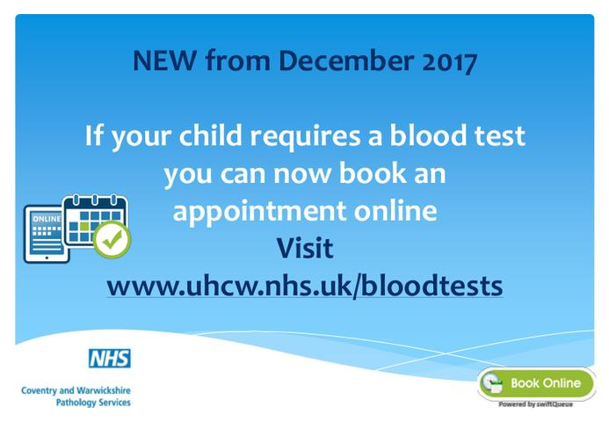

**You can make an appointment for blood tests at several locations across Coventry, Rugby and North Warwickshire. The new service helps patients, carers and family members plan their hospital visit better, and helps reduce clinic waiting times.**

**See all locations and book your appointment online at** [**www.uhcw.nhs.uk/bloodtests**](http://www.uhcw.nhs.uk/bloodtests)



**Prescription Ordering Direct (POD)**

This is a convenient effectice way to order your repeat prescription.

Telephone **02476 246072** Monday to Friday between 08:00am and 5pm and speak to a trained health professional who will order your medication for you. You will be speaking to a dedicated person who will have time to answer any repeat prescription queries and will be able to alert you if a medication review is due.

The aim of this service is to ensure patients are receiving the correct quantity of medication that they need in a timely manner to reduce the amount of prescription waste in our area. Unsused prescription medicines cost the NHS over £ 6 million every year in Coventry and Rugby alone.

Once you have made the telephone call your prescription will be authorised by your usual GP and will then be available at your nominated pharmacy 48 hours later.

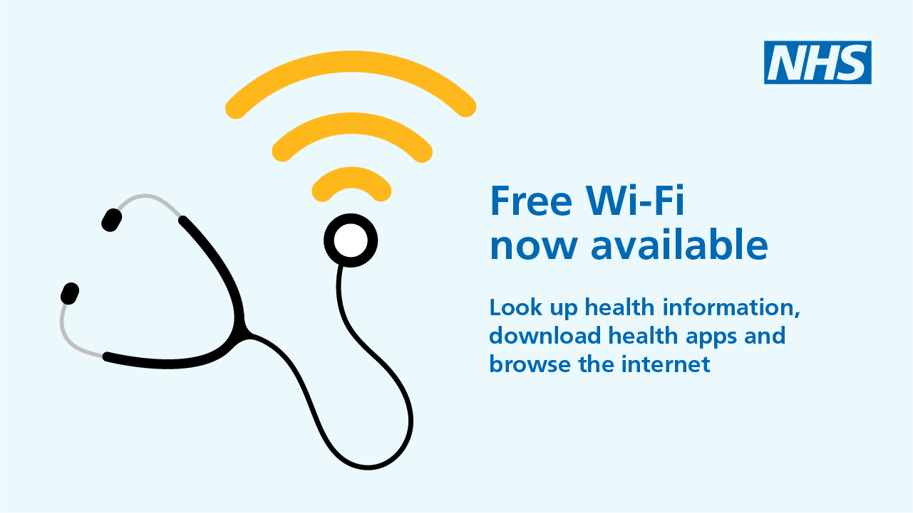

**FREE NHS Health Checks**

We are now able to offer the FREE NHS Health Checks for patients aged 40-74 who do not have a history of stroke, heart disease, kidney disease or diabetes. Eligible patients are invited to have a check once every 5 years- so don’t be surprised if you get an invite. The point of these checks is prevention so it is important that you are willing to make lifestyle changes as a result if you take up the check.

If you fit the criteria and would like to take the opportunity to have an NHS Health Check then please ask reception to arrange you an appointment.

Telephone Triage Appointments

  

We are trialling a new system on Friday mornings whereby all telephone requests for same day appointments are being dealt with by one of our GP’s. The GP will call you back, and after speaking to you on the telephone, if it is necessary for you to be seen by a health care professional, we will make arrangements for you to be seen.

Patients should be aware telephone requests should be made as early as possible after 8.30am and that the list will close if there is high patient demand.

If the list has been closed when you call you may be asked to attend a local walk in centre or offered an appointment at one of our extended hours hubs for the evening or week-end.

We would welcome your thoughts on our new system. Why not come along to our next patient participation group meeting on Thursday 1st November 2018 at 1pm and tell us your thoughts.

### EXTENDED HOURS APPOINTMENTS

We now offer GP and nurse appointments in the evening and weekends.

**To book an appointment or find out more, please speak to a practice receptionist.**

**Appointments are available at all our Extended Hours Hubs**:

# Coventry

1) Longford Primary Care Centre, (Dr Princewill & Partners), Longford Road, CV6 6DR

2) Moseley Avenue Surgery, 109 Moseley Avenue, CV6 1HS

3) Quinton Park Medical Centre, Cheylesmore, CV3 5PZ

4) Stoke Aldermoor Medical Centre, The Barley Lea, CV3 1EG

5) The Broad Street Surgery, 200 Broad Street, CV6 5BG

6) Tile Hill Surgery, Station Avenue, CV4 9HS

7) Wood End Health Centre, Deedmore Road, CV2 1XA

# Nurse Appointments

Our nurses see patients for the following appointments:

* Ear Syringing
* Dressings
* Childhood Immunisations and Vaccinations
* Cytology (smears)
* BP Checks
* Asthma Checks
* Contraception including Depo injections (the patient will need to bring the injection with them)
* Vitamin B12 injections (the patient will need to bring the injection with them)

**Did you know about 12 million don’t attend GP appointments every year?**

That is 46,000 appointments every week and costs the BHS about 162 million.

If you think you will be unable to attend your booked appointment, please let us know so we can offer it to someone else

Thank you.

Patient Participation Group( PPG)



If you would like to join our patient participation group who work positively to support the practice in improving services for patients, helping ensure we are aware of patient needs and services are appropriate and effective; why not come along to the next PPG meeting on Thursday 1st November 2018 at 1pm, here at the surgery.

**STOPTOBER**

QUITTING SMOKING IS EASIER

WITH THE RIGHT SUPPORT

3 REASONS TO QUIT:

**Feel healthier**, quitting can improve your

health right away

**Save money,** a packet a day could

save you £250 a month!

**Protect you family** from secondhand

smoke, reducing their risk of asthma

meningitis and some cancers

learn more:- **https://www.nhs.uk/oneyou/be-healthier/ quit-smoking/stoptober/**

or make an appointment with our smoking cessation nurse here at the surgery. We are here to help you STOP!

**PLEASE COMPLETE A FEEDBACK CARD**



We’d love to hear your feedback and how you think we are doing—please complete one of our feedback cards during your visit today! The cards can be found in the waiting area.

Alternatively, you could visit NHS Choices online to leave your feedback. You can access our NHS Choices page on www.nhs.uk and then typing “Willenhall Oak Medical Centre” in the search bar at the top right-hand corner of the page.