 **Willenhall Oak Medical Centre**

**SURGERY NEWSLETTER**

**September/ October 2023**



GP Registrars Dr Ehinomen Oseghale has now completed his GP training and his employment period at Willenhall Oak Medical Centre. We wish him well with his career as a GP.

Dr Mohammed Tahir and Dr Laura Page joined the team in August 2023 as GP Registrars. Dr Tahir will be with us for 16 months and Dr Page for 8 weeks, and then she will join us again in 2024.

A GP registrar is an experienced doctor who has decided on a career in General Practice. Before they come to the practice they have worked for several years as hospital doctors and are learning to adapt their medical skills and knowledge to the General Practice environment.

**FREE NHS Health Checks**

We are now able to offer the FREE NHS Health Checks for patients aged 40-74 who do not have a history of stroke, heart disease, kidney disease or diabetes. Eligible patients are invited to have a check once every 5 years- so don’t be surprised if you get an invite. The point of these checks is prevention so it is important that you are willing to make lifestyle changes as a result if you take up the check.

If you fit the criteria and would like to take the opportunity to have an NHS Health Check then please ask reception to arrange you an appointment.

**March**

**Covid Vaccination Programme**

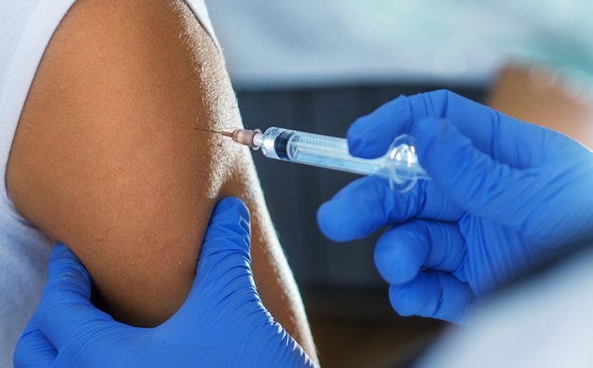

We will be delivering our autumn Covid Booster Vaccination Programme at Binley Road Cricket Club and vaccinations will be able to be booked using the booking links sent by sms invitation to eligible patients

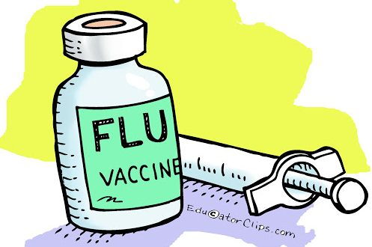

**Flu vaccination clinics**

For those who are eligible we will invite our patients to book an appointment to attend one of our flu clinics.

Our clinics are scheduled for:

Saturday’s 23rd September 2023

Saturday 30th September 2023.

More dates will be announced later.

Clinics are available for:

Anyone over the age of 65

Those aged 6 months – 65 in clinical risk groups

Pregnant women

Carers

All children aged 2 or 3 years on 31st August 2023.

Get Fitter by being a New Year Quitter

It is proven you are more likely to quit smoking with one to one support than going it alone.

We are here to support you every step of the way towards achieving a much healthier lifestyle through support and advice on reducing your risk of developing conditions and illnesses and, if you smoke, support to help you quit.

**Did you know about 12 million don’t attend GP appointments every year?**

That is 46,000 appointments every week and costs the BHS about 162 million.

If you think you will be unable to attend your booked appointment, please let us know so we can offer it to someone else

Ensure your contact phone number is up to date and you can use our text reminder service to CANCEL.

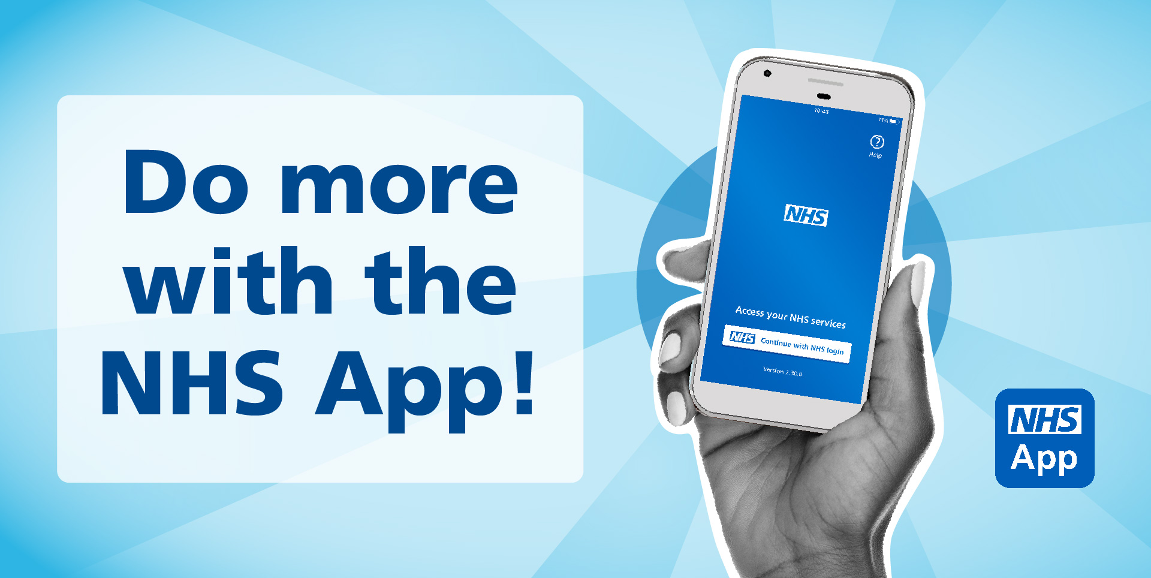

From 4th October, GP medical records will be visible for patients via the NHS App.

This includes consultations, test results, vaccinations, and clinical documents added on or after 4th October 2023. Please note that records added before this date will not routinely be visible. Patients needing medical records before this date should complete an online access form, stating requirement details or submit.a subject access.

**Helping Warwickshire residents to pay utility bills?**

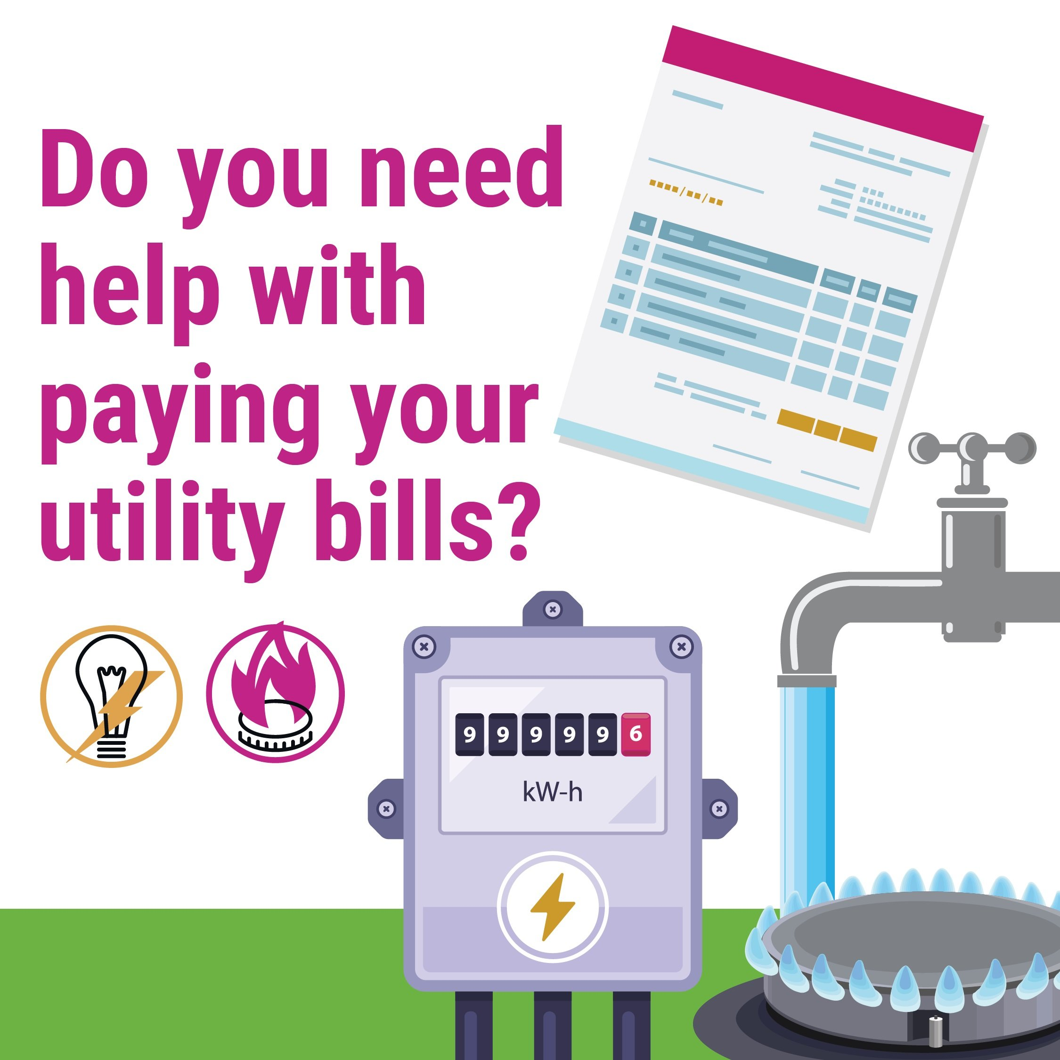

We know that sudden unexpected costs can create real challenges for residents who are experiencing financial hardship.  Vouchers towards utility bills are available for households in Warwickshire using pre-payment meters, paying by direct debit or on receipt of bill.

If you, or anyone you know, needs help please apply between 6 and 22 September 2023.  Call 0800 4081448 or 01926 359182 to talk to us in confidence.

This support is provided by Warwickshire Local Welfare Scheme and funded by the Department for Work and Pensions’ Household Support Fund.

[https://www.warwickshire.gov.uk/localwelfarescheme](https://gbr01.safelinks.protection.outlook.com/?url=https%3A%2F%2Fcwicb.net%2F5ECH-V4YC-3HZIZJ-NA6HB-1%2Fc.aspx&data=05%7C01%7Ccarrie.dickinson%40nhs.net%7Cddcfd3ba41084ad31ccd08dbb5e3f58a%7C37c354b285b047f5b22207b48d774ee3%7C0%7C0%7C638303762902594761%7CUnknown%7CTWFpbGZsb3d8eyJWIjoiMC4wLjAwMDAiLCJQIjoiV2luMzIiLCJBTiI6Ik1haWwiLCJXVCI6Mn0%3D%7C3000%7C%7C%7C&sdata=VgOTzvidQuby3u4a%2FqFTqKXq9XcIYi5Ge9ROiUOLzAc%3D&reserved=0)

[https://www.costoflivingwarwickshire.co.uk/](https://gbr01.safelinks.protection.outlook.com/?url=https%3A%2F%2Fcwicb.net%2F5ECH-V4YC-3HZIZJ-NA6HC-1%2Fc.aspx&data=05%7C01%7Ccarrie.dickinson%40nhs.net%7Cddcfd3ba41084ad31ccd08dbb5e3f58a%7C37c354b285b047f5b22207b48d774ee3%7C0%7C0%7C638303762902594761%7CUnknown%7CTWFpbGZsb3d8eyJWIjoiMC4wLjAwMDAiLCJQIjoiV2luMzIiLCJBTiI6Ik1haWwiLCJXVCI6Mn0%3D%7C3000%7C%7C%7C&sdata=9VRIMUMh%2Bdn1212qpMggIlP6z4pvnEYKf9GHv1Zmbtw%3D&reserved=0)

Clinical Pharmacist

You may receive an invite to book in to speak to a pharmacist if your medication review is due.

Appointments with our Pharmacists can be arranged by calling the practice or completing an eConsult at

[**https://florey.accurx.com/p/M86033**](https://florey.accurx.com/p/M86033)

**STAFF TRAINING DATES 2023**

Please be aware that practices across Coventry will be closed from 12:00pm on the following dates for staff training:

27th September 2023

18th October 2023

29th November 2023

Out of hours info will be available on our phone system

Get Fitter by being a New Year Quitter

It is proven you are more likely to quit smoking with one to one support than going it alone.

We are here to support you every step of the way towards achieving a much healthier lifestyle through support and advice on reducing your risk of developing conditions and illnesses and, if you smoke, support to help you quit.

**Did you know about 12 million don’t attend GP appointments every year?**

That is 46,000 appointments every week and costs the BHS about 162 million.

If you think you will be unable to attend your booked appointment, please let us know so we can offer it to someone else

Ensure your contact phone number is up to date and you can use our text reminder service to CANCEL.

**Consult us online**

You can now contact our GP practice through the NHS App. Simply use the form - or online consultation - to make your enquiry. A member of our practice will come back to you. We might be able to give you the help and advice you need, without you having to phone or come into the practice.

[**https://florey.accurx.com/p/M86033**](https://florey.accurx.com/p/M86033)