 **Willenhall Oak Medical Centre**

**SURGERY NEWSLETTER**

**October 2022**



The Partners Dr Williams is returning from maternity leave on 1st October 2022. Her new working days will be Monday, Tuesday and Thursday. Dr Kolluri will be reducing his working hours; he will be available for consultations on Wednesday, Thursday and Friday.

Salaried GP’s Dr Vineela Bojja is available for consultation on Tuesday and Wednesday’s. We would also like to welcome Dr Emily Timothy to the practice team, now employed as a salaried GP, available on Monday’s and Friday’s.

GP Registrars Dr Obasi and Dr Jalal have completed their GP training placements with us and have moved on to their next placements. We wish them well with the rest of their training.

Dr Ehinomen Oseghale and Dr Rasheed Adeniran joined the team in August 2022 as GP Registrars. They will be with us for 14 months and 6 months respectively as part of their training.

Some of our GP registrars are currently undergoing exams to complete their training. They are required to submit 13 recordings of telephone consultations as part of an exam called the Recorded Consultation Assessment. The doctor might also want to get feedback from their supervisor about the consultation and identify opportunities for improvement.

If you have a new problem that you wish to discuss with a GP and are willing to assist our trainees by having your call recorded for training purposes, please ask our reception team to book into one of these sessions.

If you consented to have the call recorded and then want change your mind, that’s absolutely fine. The recording can be deleted at any time.

https://www.fourteenfish.com/recording

**FREE NHS Health Checks**

We are now able to offer the FREE NHS Health Checks for patients aged 40-74 who do not have a history of stroke, heart disease, kidney disease or diabetes. Eligible patients are invited to have a check once every 5 years- so don’t be surprised if you get an invite. The point of these checks is prevention so it is important that you are willing to make lifestyle changes as a result if you take up the check.

If you fit the criteria and would like to take the opportunity to have an NHS Health Check then please ask reception to arrange you an appointment.

**March**



Trying to give up smoking is difficult, even if you know it is the right thing for your baby. Help is available.

Get guidance and support from trusted sources. Our experienced advisors provide a friendly, confidential service to help pregnant smokers and their families stop smoking

**Coventry Stop Smoking in Pregnancy Service**

Offers support to stop smoking for partners and other family members.

* Phone: 07904 984620 or 02476 189 190
* [Coventry Stop Smoking in Pregnancy Service on Facebook](https://www.facebook.com/CSSIPs)
* You are **three times more likely** to quit smoking with support from a stop smoking service than on your own.
* The moment you stop smoking, both you and your baby will start to feel the benefits and your journey starts here.

**https://www.happyhealthylives.uk/health-and-wellbeing/maternity-services/love-your-bump**/

**STOPTOBER**

**Quit smoking this October**

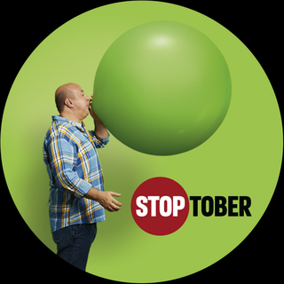

Whether you want to start breathing easier, feel the energy boost or even have a little more money to spend, there has never been a better time to stop smoking. Remember, it's never too late to join the thousands of people quitting smoking this October.

Download the free NHS Quit Smoking App to help you quit this Stoptober.

Find out more about Stoptober at: <https://www.nhs.uk/better-health/quit-smoking/>

Get Fitter by being a New Year Quitter

It is proven you are more likely to quit smoking with one to one support than going it alone.

We are here to support you every step of the way towards achieving a much healthier lifestyle through support and advice on reducing your risk of developing conditions and illnesses and, if you smoke, support to help you quit.

**Did you know about 12 million don’t attend GP appointments every year?**

That is 46,000 appointments every week and costs the BHS about 162 million.

If you think you will be unable to attend your booked appointment, please let us know so we can offer it to someone else

Ensure your contact phone number is up to date and you can use our text reminder service to CANCEL.

**MMR catch up campaign**

NHS England is undertaking a national MMR campaign that will start week commending **26th September 2022**

The campaign involves sending letters to parents of children aged 1-6 years old who have missed one or both doses or the MMR vaccine. Texts will also be sent following the letters rollout

HAVE YOU HAD YOUR FLU JAB?

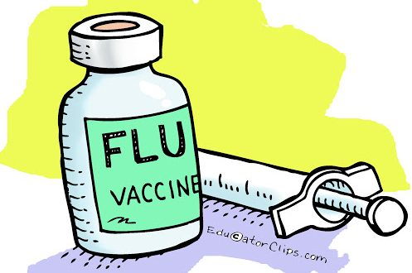

Walk In Flu vaccination clinics will commence October 2022.

For those who are eligible we will invite our patients to attend one of our flu clinics.

Our clinics are scheduled for Saturday’s 1st, 8th and 22nd October 8.30-12:00 and Thursday’s 6th, 13th and 20th October 13:00-15:30.

Clinics are available for:

Anyone over the age of 65

Those aged 6 months – 65 in clinical risk groups

Pregnant women

Carers

All children aged 2 or 3 years on 31st August 2022

Healthy 50–64-year-olds will also be eligible for a flu vaccination later in the month.

**STAFF TRAINING DATES 2022**

Please be aware that practices across Coventry will be closed from 12:00pm on the following dates for staff training:

12th October 2022

16th November 2022

Out of hours info will be available on our phone system

Get Fitter by being a New Year Quitter

It is proven you are more likely to quit smoking with one to one support than going it alone.

We are here to support you every step of the way towards achieving a much healthier lifestyle through support and advice on reducing your risk of developing conditions and illnesses and, if you smoke, support to help you quit.

**Did you know about 12 million don’t attend GP appointments every year?**

That is 46,000 appointments every week and costs the BHS about 162 million.

If you think you will be unable to attend your booked appointment, please let us know so we can offer it to someone else

Ensure your contact phone number is up to date and you can use our text reminder service to CANCEL.

**Consult us online**

You can now contact our GP practice through the NHS App. Simply use the form - or online consultation - to make your enquiry. A member of our practice will come back to you. We might be able to give you the help and advice you need, without you having to phone or come into the practice.

[**https://florey.accurx.com/p/M86033**](https://florey.accurx.com/p/M86033)

**Covid Vaccination Programme**

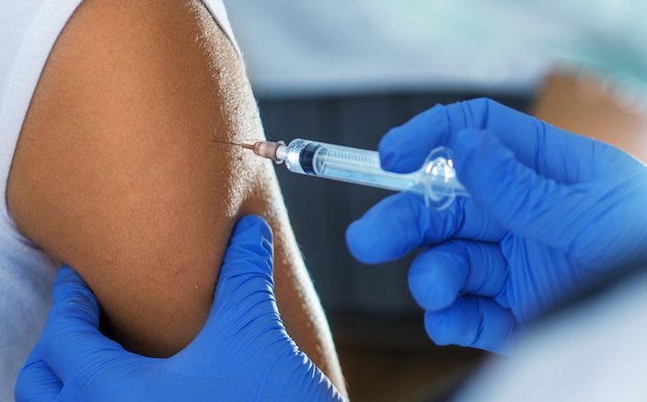

We continue to deliver our Covid-19 Vaccination Programme at Binley Road Cricket Club and vaccinations can now be booked on the national booking programme <https://www.nhs.uk/conditions/coronavirus-covid-19/coronavirus-vaccination/book-coronavirus-vaccination>.

*You may have received a text from the practice to book your Covid-19 booster vaccination. You can book your vaccination at Binley Road Cricket Club.*

*The vaccination centre is open Monday, Tuesday, Wednesday, Saturday and Sunday.*

Clinical Pharmacist

You may receive an invite to book in to speak to a pharmacist if your medication review is due.

Appointments with our Pharmacists can be arranged by calling the practice or completing an eConsult at

[**https://florey.accurx.com/p/M86033**](https://florey.accurx.com/p/M86033)

Are you a parent or carer of a pre-school child in Coventry?



Text your health visitor on 07507 329114 for confidential advice and support.

They will support you with parenting and beyond including child development, parental mental health, accidents and illnesses, infant feeding, safe sleeping