 **Willenhall Oak Medical Centre**

**SURGERY NEWSLETTER**

**MAY/JUNE 2023**

**World No Tobacco Day 31st May**.

We want to raise awareness of what you might be losing out on, both in the short and long term, both in financial losses and the impact that smoking has on appearance. For example, being able to buy products such as phones, smart watches and trainers, affording to do activities, being able to save towards a deposit to buy a house, go on holiday, re-decorate, have a brighter physical appearance, and have more energy.

Your smartwatch dream up in smoke in just 1 month- BASED ON SMOKING 10 CIGARETTES A DAY AT £11.50 PER 20 PACK



**#manmot**

On the 13th-19th June the world celebrates Men’s Health Week

##### **Our message to men:**

**It’s time for your MOT.**

* Take notice of what’s going on in your body and mind.
* Do the Forum’s quick and easy [DIY Man MOT](https://www.menshealthforum.org.uk/diy-man-mot)
* Get yourself a copy of the CAN DO manual which will also be online soon, a FREE download manual collecting together all the great ideas our [Men’s Health Champions](https://www.menshealthforum.org.uk/mens-health-champions-training) have had for things
* e can all do to boost our mental wellbeing. (If you’d like to train to be a champion in time for Men’s Health Week, you can sign up here for the [June Men’s Health Champions course](https://shop.menshealthforum.org.uk/products/health-champions-training).)
* Dig a bit deeper with our existing Man MOT manuals: [Man MOT](https://www.menshealthforum.org.uk/man-mot) and [Man MOT for the Mind](https://www.menshealthforum.org.uk/man-mot-mind).
* Get an NHS Health Check
* Go and see your GP or use [NHS 111](https://111.nhs.uk/) if you’re concerned about any symptoms

**This Men’s Health Week, it’s time for your MOT.**

**https://www.menshealthforum.org.uk**

**FREE NHS Health Checks**

We are now able to offer the FREE NHS Health Checks for patients aged 40-74 who do not have a history of stroke, heart disease, kidney disease or diabetes. Eligible patients are invited to have a check once every 5 years- so don’t be surprised if you get an invite. The point of these checks is prevention so it is important that you are willing to make lifestyle changes as a result if you take up the check.

If you fit the criteria and would like to take the opportunity to have an NHS Health Check then please ask reception to arrange you an appointment.

**STAFF TRAINING DATES 2023**

Please be aware that practices across Coventry will be closed from 12:00pm on the following dates for staff training:

Wed 24th May 2023

Wed 28th June 2023

Out of hours info will be available on our phone system

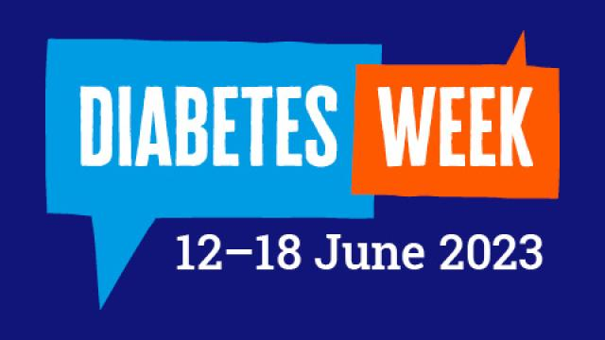

Morning blood sugar, pre-meal blood sugar, counting carbs. HbA1c, blood pressure, how many carbs were in that sandwich again? Diabetes can feel like a never-ending stream of numbers. And some days, they just don’t add up.

Diabetes doesn't stop, but neither do you. You juggle the ups and downs, you face diabetes head on every morning (whatever your blood sugar!) and you don’t let it hold you back.

So, this Diabetes Week, we want to celebrate everything that makes you, you. Because you’re so much more than your numbers.

**https://www.diabetes.org.uk/diabetes-week**

[NATIONAL PATIENT PARTICIPATION WEEK](https://www.firstpracticemanagement.co.uk/blog/2023-blog-posts/national-patient-participation-week/?utm_campaign=2334208_FPM+Bulletin+24.05++HR+Adviceline+Queries%3a+Giving+References++Patient+Participation+Week++June+Awareness+Calendar&utm_medium=email&utm_source=Stericycle+-+Customer+Experience+Account+&dm_i=2TBN%2c1E134%2c1YRM35%2c5GUEZ%2c1)- 31st may- 6th JUne 2023



The objective of having a patient Participation Group(PPG)is be a positive influence on treatment by promoting the experiences and opinions of the patients who are cared for.

Staff and patients can work together to share their thoughts ideas about future service the standard of care and the morale of all involved is boosted significantly. Patients who have a say in how services are designed and implemented come to care more for their own health and the staff who are treating them.

**If you are interested in attending our PCN Patient Participation Group meeting on 16th June 1-2pm, please let us know/ ask for details**