 **Willenhall Oak Medical Centre**

**SURGERY NEWSLETTER**

**November 2022**

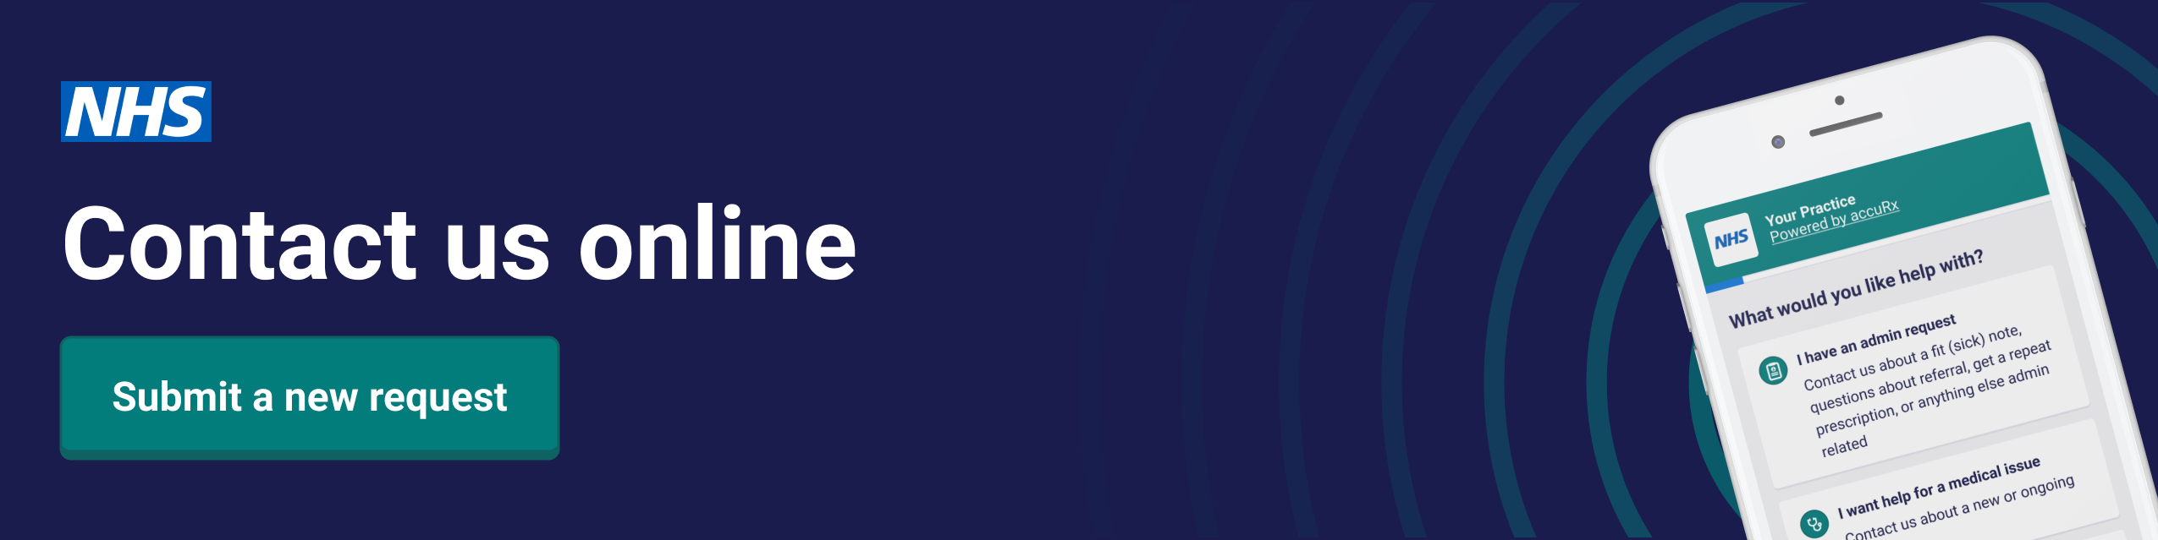

You can now contact our GP practice through the NHS App. Simply use the online consultation to make your enquiry. A member of our practice will come back to you. We might be able to give you the help and advice you need, without you having to phone or come into the practice.

[**https://florey.accurx.com/p/M86033**](https://florey.accurx.com/p/M86033)

**FREE NHS Health Checks**

We are now able to offer the FREE NHS Health Checks for patients aged 40-74 who do not have a history of stroke, heart disease, kidney disease or diabetes. Eligible patients are invited to have a check once every 5 years- so don’t be surprised if you get an invite. The point of these checks is prevention so it is important that you are willing to make lifestyle changes as a result if you take up the check.

If you fit the criteria and would like to take the opportunity to have an NHS Health Check then please ask reception to arrange you an appointment.



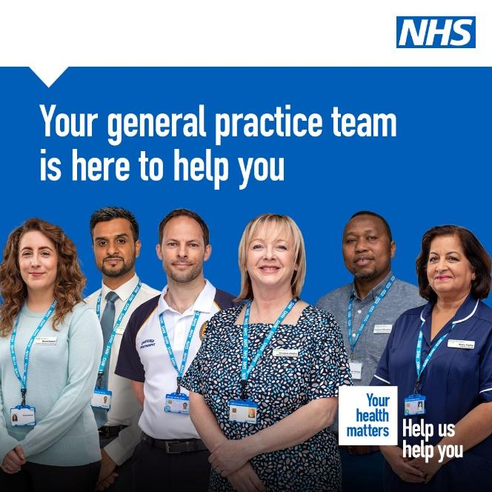

Did you know your General Practice Team is made up of a range of healthcare professionals?

Having a range of professionals at your general practice means you receive the most appropriate care as quickly as possible.

Depending on your needs, you may be seen by a member of the wider general practice team which includes dieticians, mental health therapists and health and wellbeing coaches.

Talk to your reception team to find out more about how the wider general practice team can help you.

Clinical Pharmacist

You may receive an invite to book in to speak to a pharmacist if your medication review is due.

Appointments with our Pharmacists can be arranged by calling the practice or completing an eConsult at

[**https://florey.accurx.com/p/M86033**](https://florey.accurx.com/p/M86033)

**Do you have a bone, joint, muscle or nerve pain?**

We now have a First Contact Physiotherapist (FCP) who specialises in musculoskeletal conditions offering telephone consultations remotely. They will provide:

* Expert holistic assessment and explanation/diagnosis of your condition
* Expert advice you need to start tackling the problem
* Arrange a personalised exercise program, tailored to your needs
* Arrange any necessary investigations (e.g. blood tests, x-rays, scans)
* Arrange any necessary prescriptions or sick-notes associated with your condition
* Refer onto specialist services where necessary

We strongly recommend, if you meet the inclusion criteria, you discuss your problem with the FCP instead of the GP. Face to face appointments or a review with a doctor will always be given where necessary.

Inclusion criteria, regardless of how long the problem has persisted:

* Over 16 years of age
* All soft tissue injuries, sprains, strains or sports injuries
* Arthritis
* Problems with muscles, ligaments, tendons or bones e.g. tennis elbow, carpal tunnel syndrome, ankle sprains
* Spinal problems including neck, mid back and lower back pain
* Arm or leg pain, including nerve symptoms, like pins & needles or numbness
* Post orthopaedic surgery or fracture

Community Pharmacist Consultation Service



The NHS Community Pharmacist Consultation Service is designed to help patients who need a same day appointment with a health care professional for minor illness, and improve access to services and to help to alleviate pressure on GP appointments and emergency departments.

We can make a digital referral to a convenient pharmacy for you, where you can receive pharmacist advice and treatment for a range of minor illnesses, if appropriate and you consent, your personal contact details and a short description of your presenting condition, will be transferred to the pharmacist.

If you feel this might be appropriate for you, please ask the receptionist

**March**



**Is your child up to date with their vaccinations?**

Children are offered a range of vaccinations before they start school to protect them from common but preventable infectious diseases, such as measles and polio.

Make sure your child is up to date with their vaccinations by checking the record of these in their red book. If you are unsure or know that your child needs to catch up on any missed vaccinations, send us an enquiry <https://florey.accurx.com/p/M86033>



Trying to give up smoking is difficult, even if you know it is the right thing for your baby. Help is available.

Get guidance and support from trusted sources. Our experienced advisors provide a friendly, confidential service to help pregnant smokers and their families stop smoking

**Coventry Stop Smoking in Pregnancy Service**

Offers support to stop smoking for partners and other family members.

* Phone: 07904 984620 or 02476 189 190
* [Coventry Stop Smoking in Pregnancy Service on Facebook](https://www.facebook.com/CSSIPs)
* You are **three times more likely** to quit smoking with support from a stop smoking service than on your own.
* The moment you stop smoking, both you and your baby will start to feel the benefits and your journey starts here.

**https://www.happyhealthylives.uk/health-and-wellbeing/maternity-services/love-your-bump**/

Get Fitter by being a New Year Quitter

It is proven you are more likely to quit smoking with one to one support than going it alone.

We are here to support you every step of the way towards achieving a much healthier lifestyle through support and advice on reducing your risk of developing conditions and illnesses and, if you smoke, support to help you quit.

**Did you know about 12 million don’t attend GP appointments every year?**

That is 46,000 appointments every week and costs the BHS about 162 million.

If you think you will be unable to attend your booked appointment, please let us know so we can offer it to someone else

Ensure your contact phone number is up to date and you can use our text reminder service to CANCEL.

Are you a parent or carer of a pre-school child in Coventry? 

Text your health visitor on 07507 329114 for confidential advice and support.

They will support you with parenting and beyond including child development, parental mental health, accidents and illnesses, infant feeding, safe sleeping

**Every Mind Matters- Be kind to your mind**

Do you have a low mood, trouble sleeping or find yourself aimlessly scrolling through social media?

There are small things we can all do to help be kind to our mind and these can make a big difference to how we feel.

Every Mind Matters has NHS-approved advice and simple tips to help you look after your mental wellbeing and see whether you can make them part of your daily routine.

[Answer 5 simple questions](\\\\cwss.nhs.uk\\ndc\\GP_HOME\\dickinsonc\\Carrie's Folder\\newlsetters\\Answer 5 simple questions) (<https://www.nhs.uk/every-mind-matters/mental-wellbeing-tips/your-mind-plan-quiz/>)to get a free, personalised mental health action plan, with tips to help you deal with stress and anxiety, boost your mood, sleep better, and feel more in control.

As the colder months are approaching, it is important to have [your winter vaccinations](https://www.nhs.uk/conditions/vaccinations/flu-influenza-vaccine/) to protect you and those around you who may be vulnerable. Some people may be eligible for both flu and COVID-19 booster vaccines. If you are offered both vaccines, it’s safe to have them at the same time.

COVID-19 is still in circulation and indications are that cases are rising again. Despite a very few cases of flu last year health experts suggest it may be in wider circulation this winter.

It is possible to have both illnesses at the same time so having the vaccinations reduces the likelihood of serious illness should you get flu and / or Covid.

If you have been invited for a flu vaccine please book in with reception

We continue to deliver our Covid-19 Vaccination Programme at Binley Road Cricket Club and vaccinations can now be booked on the national booking programme <https://www.nhs.uk/conditions/coronavirus-covid-19/coronavirus-vaccination/book-coronavirus-vaccination>

Get Fitter by being a New Year Quitter

It is proven you are more likely to quit smoking with one to one support than going it alone.

We are here to support you every step of the way towards achieving a much healthier lifestyle through support and advice on reducing your risk of developing conditions and illnesses and, if you smoke, support to help you quit.

**Did you know about 12 million don’t attend GP appointments every year?**

That is 46,000 appointments every week and costs the BHS about 162 million.

If you think you will be unable to attend your booked appointment, please let us know so we can offer it to someone else

Ensure your contact phone number is up to date and you can use our text reminder service to CANCEL.

**STAFF TRAINING DATES 2022**

Please be aware that practices across Coventry will be closed from 12:00pm on the following dates for staff training:

16th November 2022

Out of hours info will be available on our phone system