Willenhall Oak medical Centre newsletter

January 2023

Happy New Year 2023

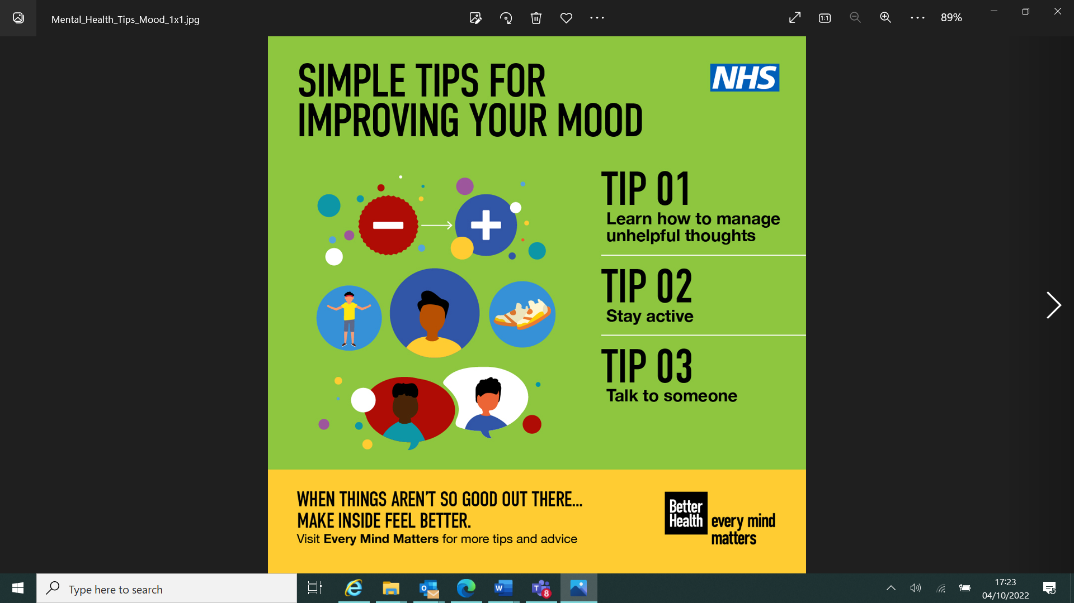

If you’re struggling with your mental health, you are not alone. Trouble sleeping, drinking, or eating excessively can all be indicators that your mental health may need some TLC.

The NHS can help you get your feet back on the ground.

[Every Mind Matters](https://www.nhs.uk/every-mind-matters/?WT.mc_id=MentalHealthGeneric&gclid=EAIaIQobChMIs6f3v__G-gIViO_tCh33nAurEAAYASAAEgL1ZPD_BwE&gclsrc=aw.ds) web support can help as well as services such as [Talking Therapies](https://www.nhs.uk/service-search/mental-health/find-a-psychological-therapies-service/). You can refer yourself to these.

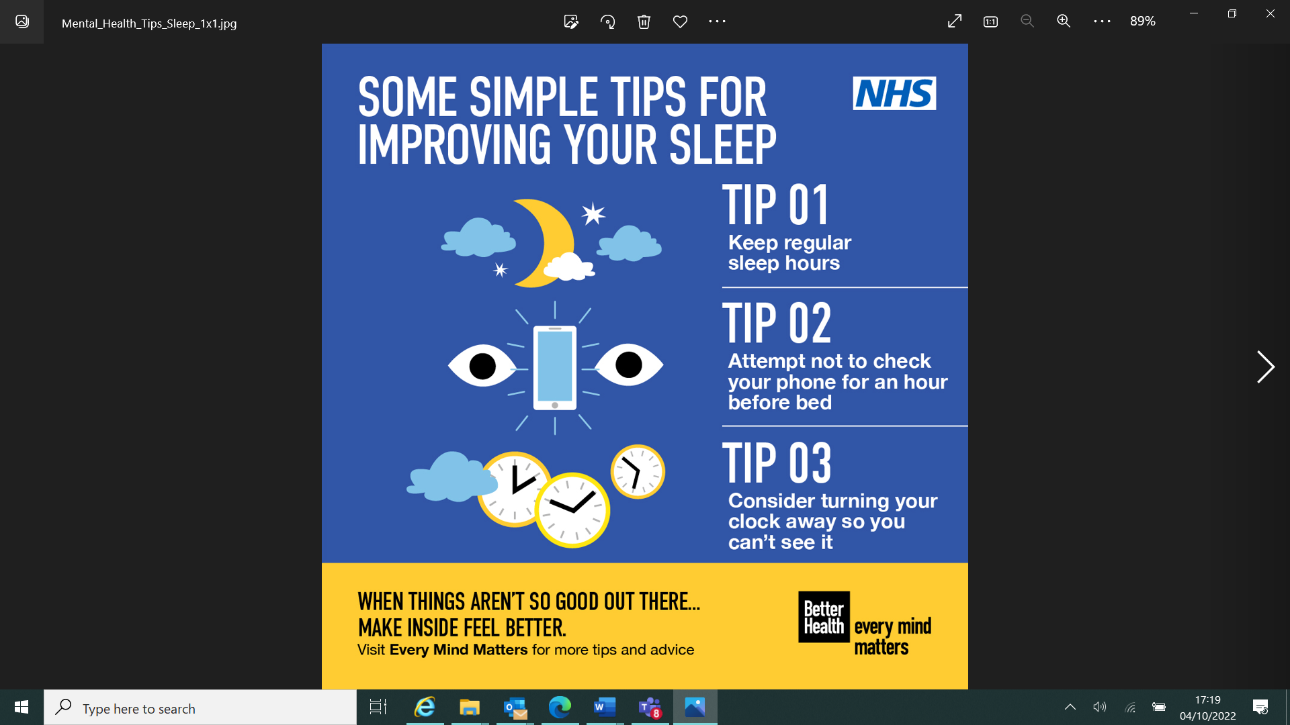

**Every Mind Matters- Be kind to your mind**

There are small things we can all do to help be kind to our mind and these can make a big difference to how we feel.

Every Mind Matters has NHS-approved advice and simple tips to help you look after your mental wellbeing and see whether you can make them part of your daily routine.

https://www.nhs.uk/every-mind-matters

In January the NHS is anticipating an increase in winter illnesses such as Strep A; norovirus; RSV; Covid-19 and flu.

The NHS is experiencing an incredibly busy winter period. We want to help you to get the health care that’s right for you.

Group A Strep (GAS) is a common bacteria which causes a range of infections. These are usually mild.

As a parent if you feel your child is seriously unwell call 111 or speak to your GP.

For more information visit https://**www.nhs.uk/conditions/strep-a/**

Do you have norovirus?

If you feel sick, have diarrhoea and a high temperature, you might have the ‘winter vomiting bug’ known as norovirus.

If you have norovirus, stay at home and avoid close contact with others for 48 hours after your symptoms clear, wash your hands with soap and water and don’t prepare food for others.

For more information please visit <https://www.nhs.uk/conditions/norovirus>.

RSV is a common virus causing colds and coughs but can be more severe in some children. Right now, cases are higher than usual for this time of year.

If your child is breathless, has a persistent high temperature or isn’t feeding properly, contact NHS 111 or your GP as it could be a sign of severe respiratory illness.

Find out more about the symptoms and what to do if you’re concerned here **https://www.nhs.uk/conditions/bronchiolitis/**

NHS 111

If you have an urgent care need NHS111 online can help to make sure you get the medical help you need. It may save a telephone call or a trip to the hospital. And there are healthcare professionals who will call you if needed.

NHS111 links to all our local services so should only recommend services that are right for you and open when you need them.

You can also find NHS111 online on your NHS App. This can be downloaded from your usual app store



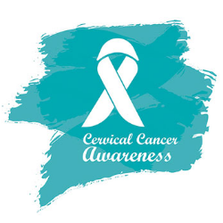

**CERVICAL CANCER PREVENTION WEEK( 23-29 JANUARY 2023)**

Cervical cancer is the most common cancer in women aged 30 to 35 and is the fourth most common cancer in women globally. In the UK, an average of 3,200 cases of cervical cancer are detected each year, with 51% surviving cervical cancer for 10 or more years. But a staggering 99.8% of these cases could be preventable by getting vaccinated against HPV and attending regular cervical screening tests when you are advised to go.

When detected early, cervical cancer is one of the most successfully treatable cancers.

#### **What is Cervical Screening?**

Cervical screening is just one of the ways of preventing cervical cancer. It is a test that checks the health of the cervix, primarily looking for any signs of HPV and picking up any abnormalities in cells that could lead to cancer. HPV is linked to almost all cases of cervical cancer. Cervical screening is available to all women in the UK aged between 25 to 64, and depending on where you live an invite will be sent every 3 to 5 years. First invites are usually sent 6 months before your 25th birthday.

In England invites will be sent every 3 years if you are aged between 25 to 49; after that, invites are sent every 5 years until the age of 64.

In England, a test known as the HPV primary screening is carried out during cervical screening and this can bring back a number of results, which include:

* **No HPV found –**you don’t have high-risk HPV
* **HPV found –** **no cell changes –**you have high-risk HPV but no changes to the cells have been detected
* **HPV found –** **cell changes found –** you have high-risk HPV and cell changes have been detected
* **Inadequate –** the sample could not be tested properly or does not have enough cells.

**Are you due for screening?** Book your appointment with the practice nurse.